CmpE 110 LAB 2 Dr. A. Bindal

DIODE CIRCUITS

Part 1: Simple diode circuits

Construct the diode circuit below with VCC = 5V and 1N4001 rectifying diode from LTSPICE database. Measure the output voltage at vout, which should be around 0.7V. Allow only 10mA through the circuit. Re-compute the value of the resistor RD such that ID would be 1mA and 100mA. Does the output voltage change in each case? Record your values in an Excel table.
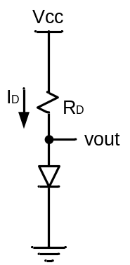

Now, replace the supply voltage, VCC, with a sinusoidal voltage source from your waveform generator whose maximum amplitude changes between +/-10V with a frequency of 100Hz as shown below (this requires to add an sinusoidal waveform generator from the LTSPICE database with correct amplitude and frequency entries). Determine R such that the AC current through the circuit is less than 10mA. Record the output waveform.

Now attach a parallel capacitor, C, to the output resistor as shown in the figure below. Adjust the value of the capacitor such that the output ripple voltage (the difference between max and min output voltage values) becomes less that 100mV.

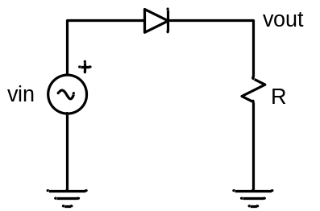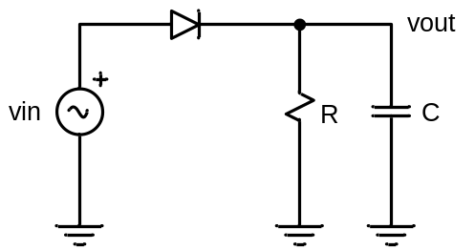

Part 2: Zener diode circuit

Construct the diode circuit below with VCC = 10V and a Zener diode with 3.3V and then 5V voltage ratings from the LTSPICE database. Determine RZ such that the current through the circuit does not exceed the rated current level of the Zener diode. Measure the output voltage at vout to see if it is 3.3V.

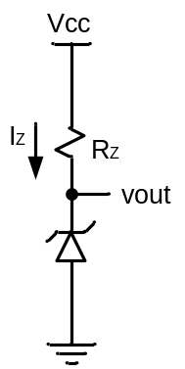

Part 3: Light Emitting Diode (LED) circuit

Construct the diode circuit below with VCC = 10V and LED from the LTSPICE database. Determine RL such that the current through the circuit does not exceed the rated current level of the LED. Measure the output voltage at vout and tabulate your results.

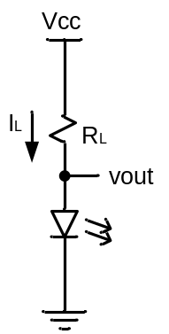

Part 4: Simple bipolar circuits

Construct the bipolar circuit below using the NPN transistor, 2N3904, from the LTSPICE database. The current gain, h_{FE}, for this transistor changes between 100 and 150, depending on the base current level (divide the collector current to the base to find h_{FE}) from the output characteristics as shown below.

Attach 10V power supply voltage to the base and collector as shown below, and determine Rb and Rc to operate the transistor in active and saturation region.

(a) Find the currents in the base and collector such that the transistor operates in the middle of active region with OUT = V_{CE} = 5V.

(b) Find the currents in the base and collector such that the transistor operates in saturation region where IBSAT >> IBACT, i.e. IBSAT ≈ 3xIBACT.

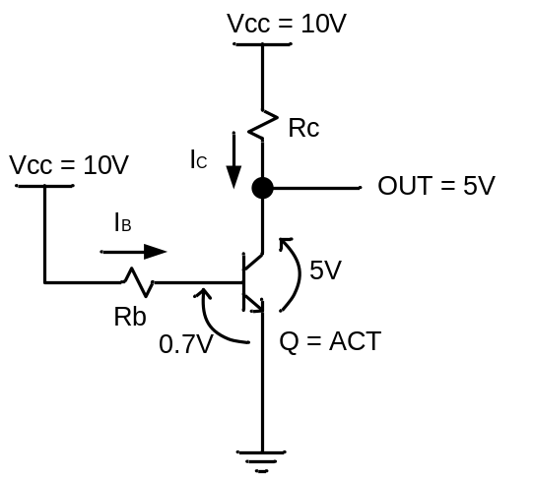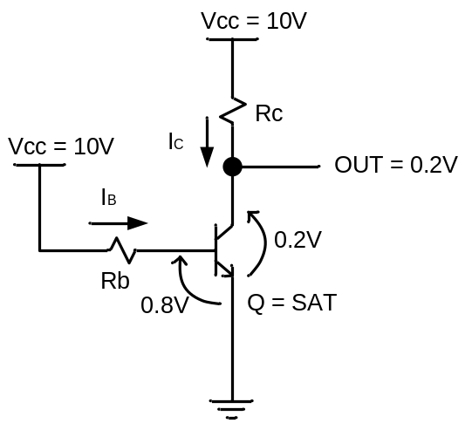

You may use the sample output I-V characteristics below to give you an idea. However, in order to accomplish the projected design, you need to change the resistor values until appropriate input and output voltages are obtained. Record your voltage and current values when the desired quiescent point for each circuit is reached.

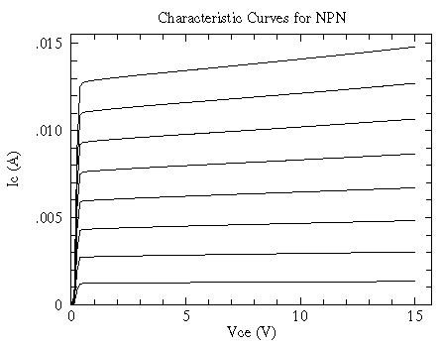
For I_{B} = 10 µA (the lowest curve), 20 µA, 30 µA, ... , 80 µA (the highest curve).

